Testing Steps for Dev Environment
- Material Quantity
- Material Quantity
Here you can select group and then process. Then you can estimate the Time & Material require as per your requirement(Area for which you wish you paint)
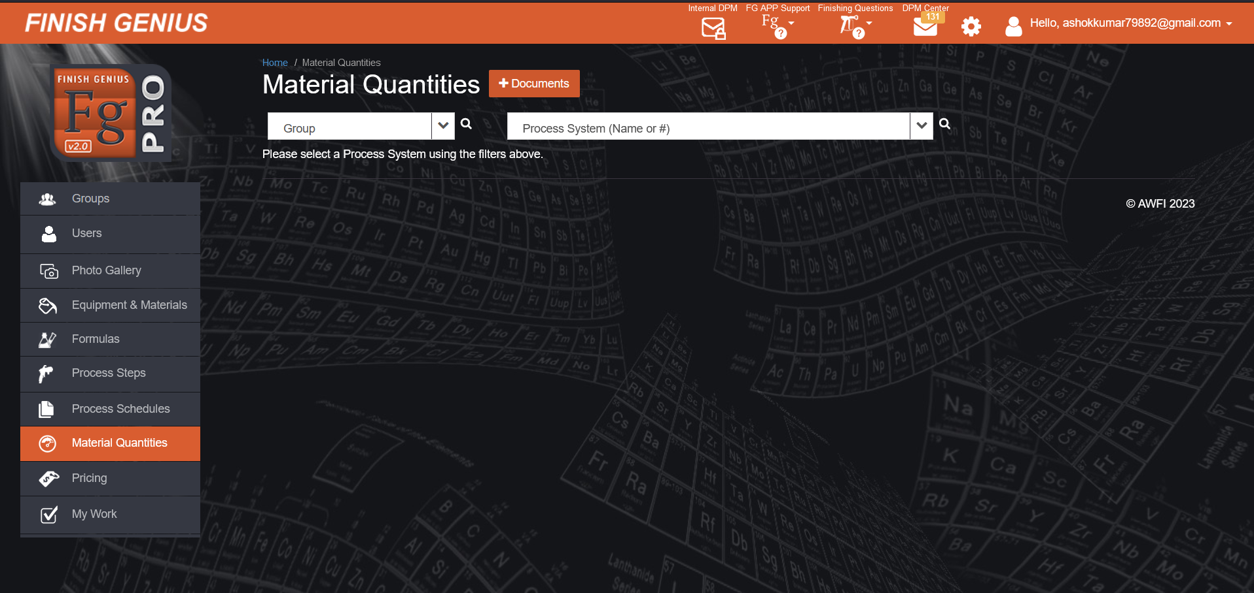

Step-1 Select Group and then process
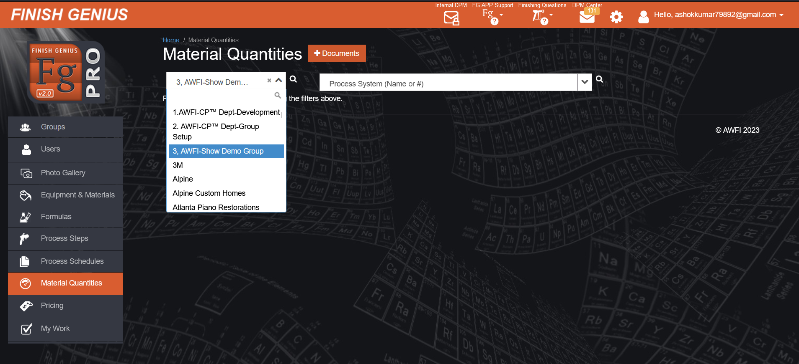

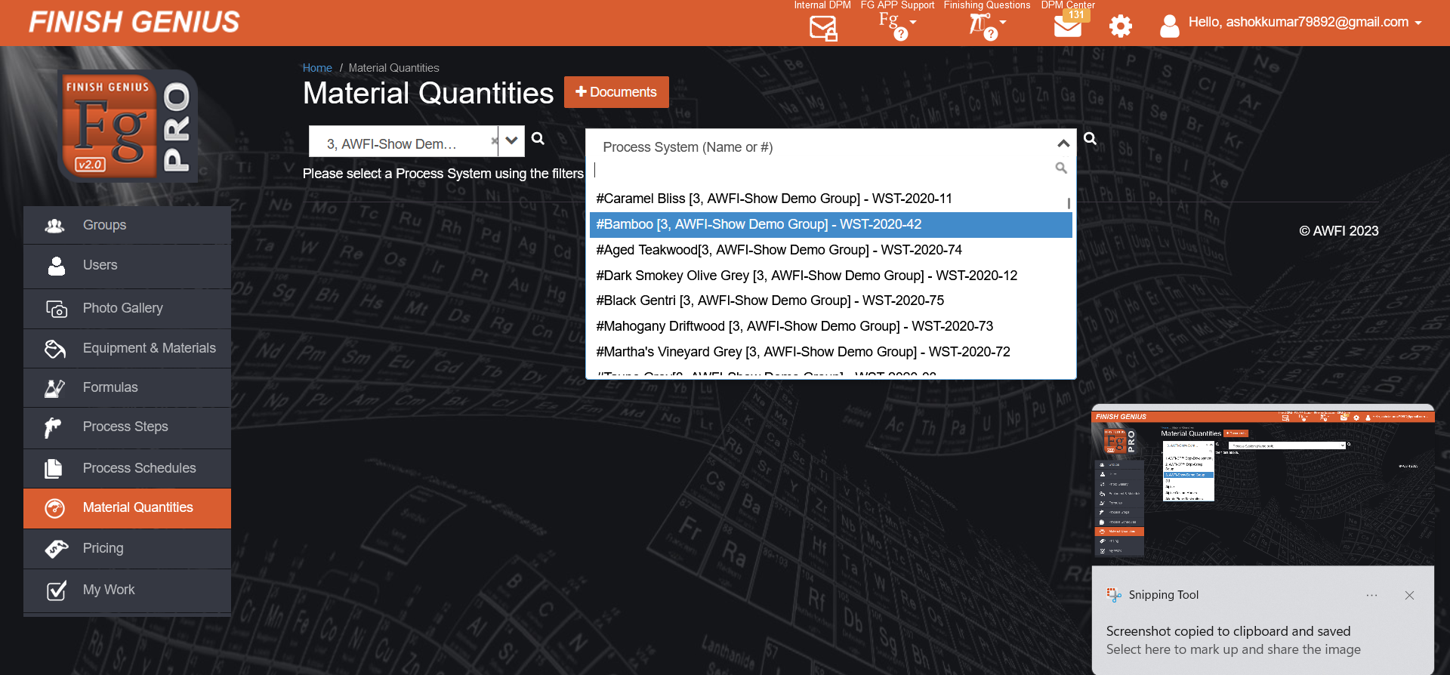

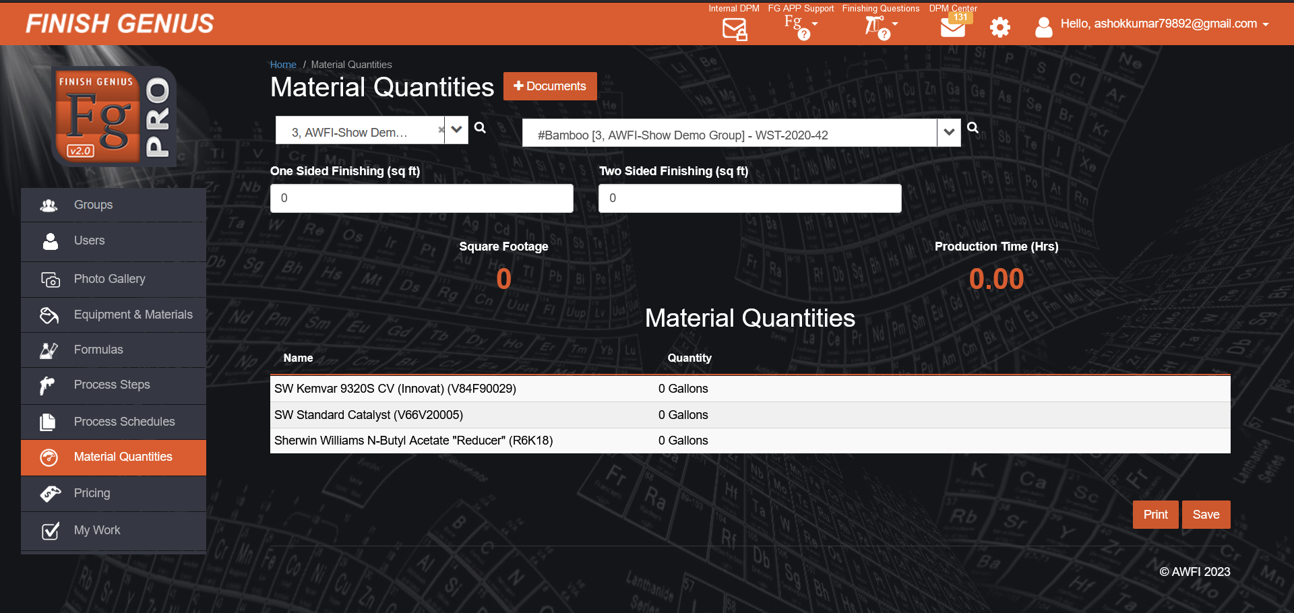

Step-2 Enter the are for which you want to know Material Quantities and Production Time Required
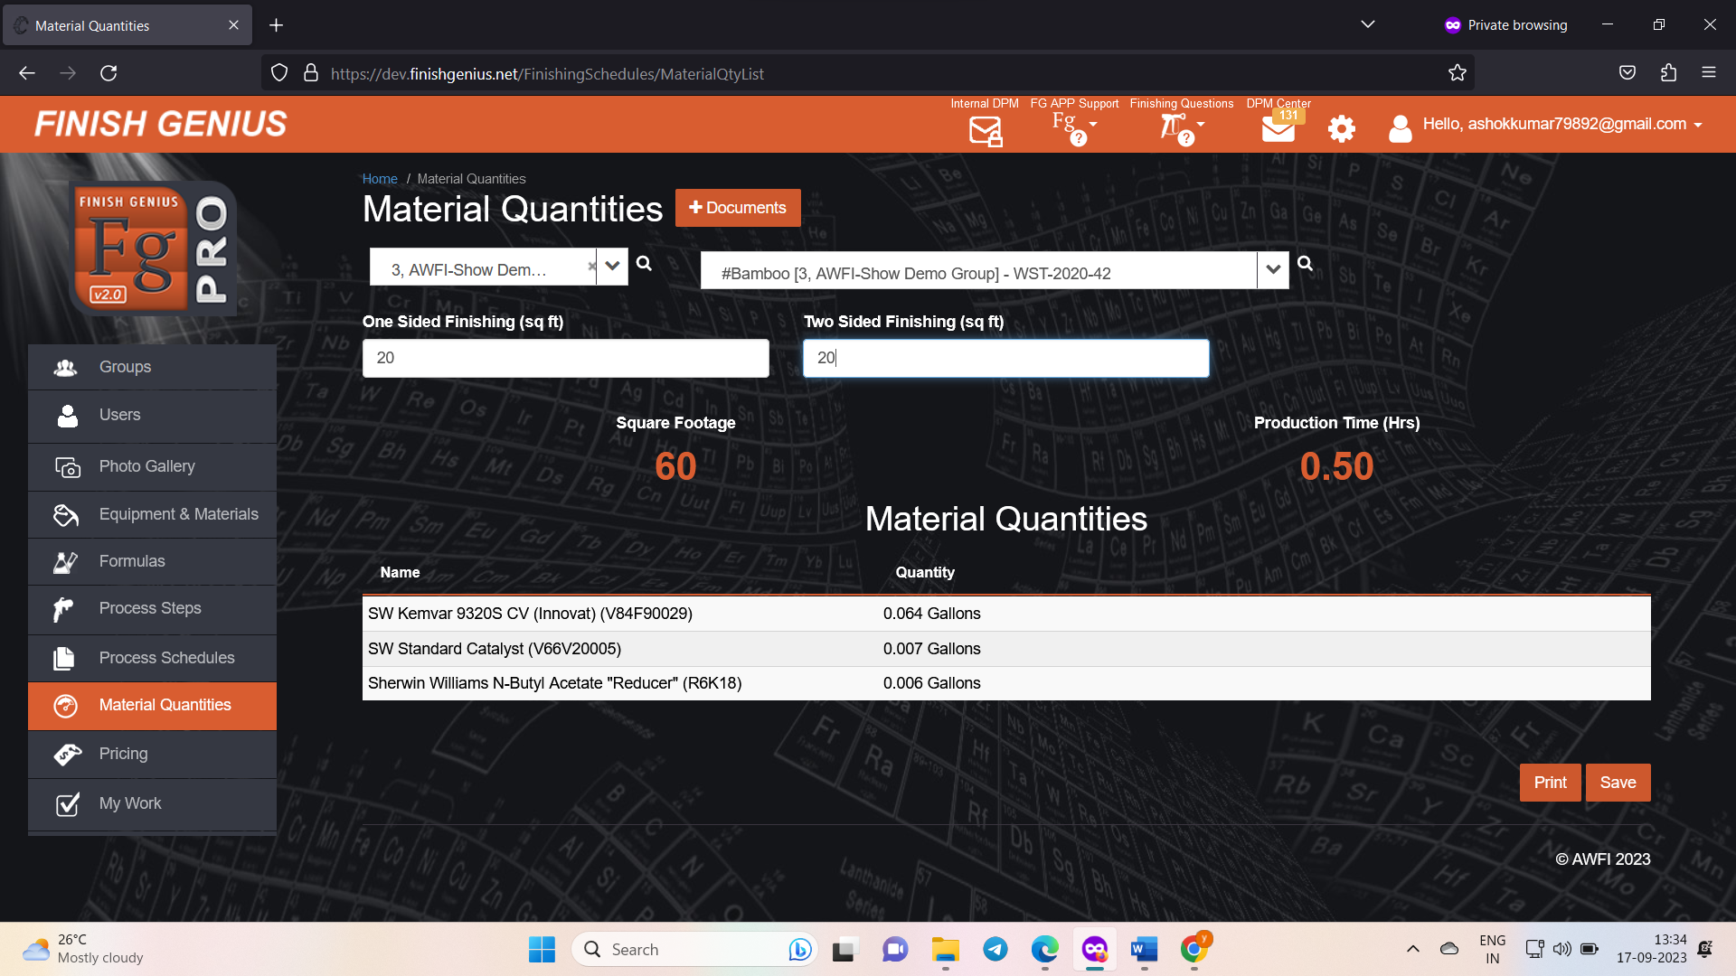

Conclusion
- Material Quantities is working properly

